2015 MEESO International Conference

General Information_____________________________________________

Theme: Building Blocks of English Teacher Training: Policy and Professionalism
Date: August 19, 2015 (Wednesday) 9:00~17:50
Venue: Konkuk University, Seoul, Korea

Plenary Speakers_______________________________________________

Emiko Yukawa (Ritsumeikan University, Japan)
Topic: EFL Teacher Training in Japan: Practice, Outcome, and Problems

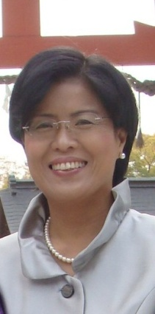 | - Professor in the College of Letters at Ritsumenikan University  - Training future secondary school English teachers  - Supporting a number of elementary and junior high schools in Japan by offering in-service teacher training  - Research areas: English education at primary/secondary schools, bilingual education, and language attrition

Yin Ling Cheung (Nanyang Technological University, Singapore)
Topic: Assessing Student Teachers’ Writing Quality through Pen-and-paper Versus Computer-delivered Assessment Modes

 | - Professor in the Department of English Language and Literature at Nanyang Technological University  - Ph.D. in Linguistics at Purdue University  - Visiting Researcher at Leiden University (Netherlands)  - Researcher in the Indigenous and Endangered Languages Lab at Purdue University  - Research areas: Second language writing, writing for academic purposes, writing across the curriculum, writing teacher education, and writing assessment

Cheng Xiaotang (Beijing Normal University, China)
Topic: What Prevents Novice English Teachers from Using the Methods Learned in Pre-service Teacher Education?

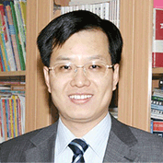 | - Dean and professor in the School of Foreign Languages and Literatures at Beijing Normal University  - Member of the English Curriculum Standards Panel commissioned by the Chinese Ministry of Education  - Research areas: Discourse analysis, ELT methodology, syllabus design, materials development, and teacher education

Featured Speaker_______________________________________________

Hyoshin Lee (Konkuk University, Korea)
Topic: The Outcomes and Prospects of English Language Teacher Education Policy in South Korea

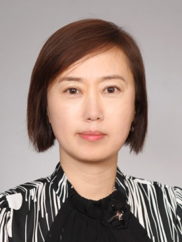 | - Professor in the Department of English Language at Konkuk University  - Twenty years of teaching experience at state secondary schools  - Developed a five-month residential intensive teacher training programme implemented by Seoul Metropolitan Office of Education  - Managing editor of the Journal of Asia TEFL  - Research areas: School-based teacher development, teacher education policy, teaching methodology

